EIC LAPTOP LOANER PROGRAM: Checkout and Liability Form
Laptop/FIU Tag No. _________________
Value: $ 1,300.00 (Includes: case, 1GBytes, battery, and power supply)
As the Borrower, you have been provided with the loan of a laptop computer with above FIU Tag No. In consideration of the right to use the laptop computer, the Borrower agrees to abide by the following terms and conditions:
- The Borrower agrees to keep the laptop computer in his or her custody and agrees not to loan, or otherwise provide the computer to any other person. The Borrower agrees not to violate the laws of any state or of the United States with regard to trademark, copyright, patent, libel, slander, the privacy of electronic data communication.
- The Borrower agrees to inform the College immediately of any problems, malfunctions, damages, loss or theft of the computer. The Borrower assumes all responsibility for any damage, loss or theft of the laptop computer.
- The borrower agrees to return the Computer System to EIC within 7 days, in the same condition as on the Agreement beginning date, reasonable wear and tear. Laptops cannot be reissued to the same student on the day they are returned.
- A late fee in the amount of $25.00/day will be charged for not bringing the laptop back on time. You must return this laptop no later than ______________
Laptops not returned within 24 hours of the agreed upon return date will be considered stolen. FIU police will be contacted and a hold will be placed on your FIU account. Individual cases may be referred to Student Affairs for disciplinary action.

Laptop/FIU Tag No:
Date of checkout/renewal | Expected  Date of return | Borrowers Signature
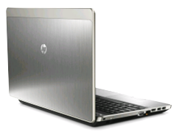
I hereby acknowledge the receipt of the above-listed property in the conditions specified in the Existing Damage Report Form (initial ) and am aware of the responsibility for its care and return. Furthermore, I authorize the Engineering Information Center (College of Engineering) to charge any liabilities arising under this Agreement against my student account at Florida International University.
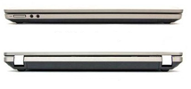

Notes:

Borrower’s name: ______________ _ _ ________ Panther ID: _______________________
Borrower’s email: _________________________ Cellphone #: _______________________
Borrowers Signature X______________________ Date: ________________
Equipment distributed by: _____________________
Equipment received by: __ Date: __

